Title: Implement the node js application in project.

Team Members:

|  |  |
| --- | --- |
| NAME | GR NO |
| Shivam Parve | 17u113 |
| Sanket Sonje | 17u176 |
| Shreyash Mule | 17u125 |
| Suyog Salpure | 17u111 |
| Pranav Patil | 17u030 |
| Aboli Rode | 21820128 |

Aim:

To implement the node js in application to implement the backend of web application

Title:

Todo list using node js, vue js ,and mongodb.

Objective:  
Implement the node js in project.

Theory:

**Node js:**

Node.js is an open-source runtime environment for server-side and networking applications and is single-threaded.

It uses the Google JavaScript V8 Engine to execute code.

It is a cross-platform environment and can run on Microsoft Windows Linux, FreeBSD, and IBM

It provides an event-driven architecture and non-blocking I/O that is optimized & scalable.

**Front End:**

In this assignment the front end is developed with node js. The get , put delete request are send from front end to the server .

in front end the router concept is used using which we can redirect the request to particular page according to URL.

The response form serve is stored in local variable and it is updated dynamically to user using model attribute of vue js.

**Backend:**

The backend is developed using the node js. The server side use the concept of node js to implement the backed.

In the back end the model class are used which maps the data base . all the request are first mapped to model class then it is mapped to data base using

Model class functions.

Each CRUD operation in data base is done using this model class.

**Data Base:**

The mongodb is used as data base . the connectivity to mongodb is done through

Mongoose library in node js. Mongo db is non relational data base . the ID of each entry is used to perform crud operations on them.

**Output:**

Inserting a task:

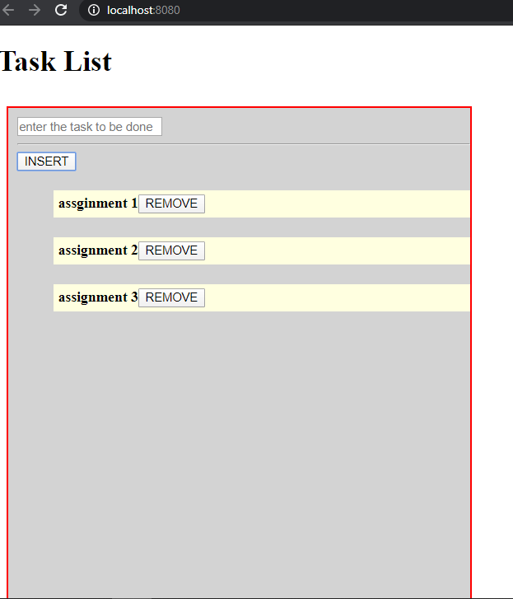

Deleting a task:

